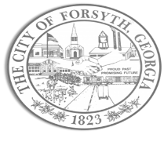
Agenda
Council Meeting
January 16, 2024
23 East Main Street 6:00 p.m.

- Call to Order
- Pledge of Allegiance, Invocation, and Roll Call.
- Executive Session
- Approval of the agenda.
- Approval of the minutes from the council meeting held on January 2, 2024.
- Approval of an intergovernmental agreement with Monroe County to house, board, and incarcerate prisoners, arrestees, and detainees of the City.

- Approval to begin design and bidding process with Hofstadter & Associates for the Railroad Avenue Water Line.

- Boundary decision of city property; Sharp St to Powell Street right of way.
- Approval of Requisitions Greater than $6,000
- Core & Main, LP $70,636.00
- Gresco Utility Supplies, Inc $6,211.00

- City Manager’s Report
- City Attorney Report
- Mayor’s Report
- Additional Business
- Public Comments
- Adjourn

Individuals with disabilities who require certain accommodations to allow them to observe and/or participate in this meeting, or who have questions regarding the accessibility of Aldermen Hall can contact the City Clerk, Regina Ivie at 478-994-5649 or rivie@cityofforsyth.com. If additional accommodations are needed requests should be made as soon as possible but no less than 24 hours prior to the scheduled meeting.

