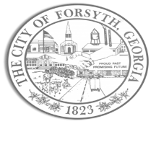

Agenda

City of Forsyth Council Retreat
Indian Springs State Park
678 Lake Clark Rd Flovilla, GA 30216

January 31, 2024 @ 9:00 a.m.

- Call to Order

- Project Updates

- Departmental Updates

- Annexation Discussion

- Lunch

- Council Goals

