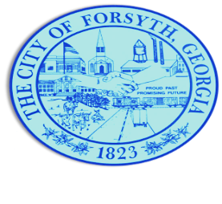
Agenda
Forsyth City Council Meeting
February 19, 2024
23 East Main Street @ 6:00 p.m.

- Call to Order
- Pledge of Allegiance, Invocation by Lloyd Strickland, and Roll Call
- Approval of the agenda.
- Approval of the minutes from the council meeting held on February 5, 2024.
- Approval to award bid to Renfroe Construction for Country Club Park.
- Approval of temporary permit for the sale of alcoholic beverages for El Dorado Mexican Restaurant on March 8th, 9th, and 10th.

- Approval of a temporary permit for the sale of alcoholic beverages for Fox City Brewing on March 9th.
- Approval of a street closure request on February 24, 2024 for Malik Herring Day Parade.
- Approval of a street closure request on March 2, 2024 for the Forsythia Festival 5K Race.
- Approval of a street closure request on March 8, 2024 through March 11, 2024 for the Annual Forsythia Festival.

- Approval of Requisitions Greater than $6,000
  - Allsouth Environmental Services, Inc. $14,020.95
  - Davis Plumbing Company $16,867.00
  - Freedom Fireworks $13,500.00
- Public hearing to consider amendment to Article 10, (Nonresidential Zoning Districts) Table 10.1
- Public hearing to consider a variance request regarding Article 10, Non-Residential Zoning Districts, Table 10.1.

- Walter Goodson
- City Manager’s Report
- City Attorney Report
- Mayor’s Report
- Additional Business
- Public Comments
- Executive Session (if necessary)
- Adjourn
Individuals with disabilities who require certain accommodations to allow them to observe and/or participate in this meeting, or who have questions regarding the accessibility of Aldermen Hall can contact the City Clerk, Regina Ivie at 478-994-5649 or rivie@cityofforsyth.com. If additional accommodations are needed requests should be made as soon as possible but no less than 24 hours prior to the scheduled meeting.

