-- -
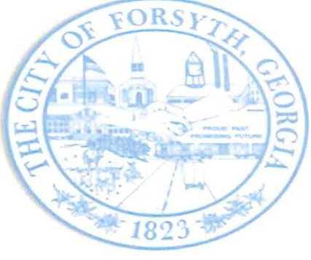

Agenda
Forsyth City Council Meeting March 4, 2024
23 East Main Street @ 6:00 p.m.

I.
II. III. IV.
V.
VI. VII. VIII.
IX.
X.
XI.

XII. XIII. XIV.

xv.
XVI. XVII. XVIII. XIX.
Call to Order
Pledge of Allegiance, Invocation and Roll Call Approval of the agenda
Approval of the minutes from the council retreat held on January 31, 2024 and the council meeting February 19, 2024.
Swearing in of Assistant City Clerk, Shayla Furlow
Community Development Block Grant Conflict of Interest Disclosure by Dean Nelson Approval of a Limited Warranty Deed unto Bran Hospitality Forsyth, LLC
Approval of Municipal Competitive Trust Withdrawal Request Approval to award bid for Willis Wilder Drive
Walter Goodson
Approval of Requisitions Greater than $6,000
1. Davis Plumbing Company- $10,604.00
11. Calibration Controls & Automation- $9,500.00

City Manager's Report City Attorney Report Mayor's Report Council Board Reports Additional Business Public Comments
Executive Session - Personnel Matters Adjourn

Individuals with disabilities who require certain accommodations to allow them to observe and/or participate in this meeting, or who have questions regarding the accessibility of City HaU can contact the City Clerk, Regina Ivie at 478-994-5649 or rivie@cityofTorsyth.com. If additional accommodations are needed requests should be made as soon as possible but no less than 24 hours prior to the scheduled meeting. •

