Agenda
Forsyth City Council Meeting
January 20, 2026
23 East Main Street @ 6:00 p.m.

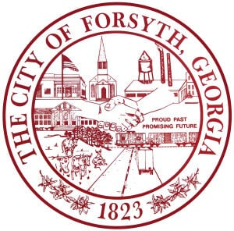

- Call to Order
- Pledge of Allegiance, Invocation, and Roll Call
- Approval of the agenda.
- Approval of the minutes from the council meeting held on January 5, 2026.
- Approval of the annual board appointment for the Monroe County Development Authority
- Consideration and approval of amendment to the 2026 List of Professionals to include Alyssa
Peters, Chief Municipal Court Judge.
- Approval of street closure request on March 28, 2026 for the 9th Annual Fit to Achieve 5k.
- Approval of street closure request on March 7, 2026 for the Forsythia 5k.
- Approval of street closure request on March 14-15, 2026 for the Annual Forsythia Festival.
- Approval of bid award to Davis Plumbing Company Services for an emergency culvert repair
Sharp Street.
- Approval of requisitions greater than $6000
- Davis Plumbing Company- $23,728.00
- Cummins Sales & Service- $7,947.72
- Water Task Force Update
- City Manager’s Report
- City Attorney Report
- Mayor’s Report
- Additional Business
- Public Comments
- Executive Session (litigation)
- Adjourn

Individuals with disabilities who require certain accommodations to allow them to observe and/or participate in this meeting, or who have questions regarding the accessibility of City Hall can contact the City Clerk, Shayla Furlow at 478-994-5649 or sfurlow@cityofforsyth.com. If additional accommodations are needed requests should be made as soon as possible but no less than 24 hours prior to the scheduled meeting.

