**Agenda**

**Forsyth City Council Meeting**

**October 20, 2025**

**23 East Main Street @ 6:00 p.m.**

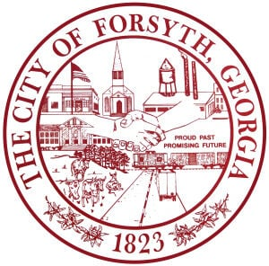

1. **Call to Order**
2. **Pledge of Allegiance, Invocation, and Roll Call**
3. **Approval of the agenda.**
4. **Approval of the minutes from the council meeting held on October 6, 2025.**
5. **Public Hearing for the 2026 Proposed Budget**
6. **Convention & Visitors Bureau Quarterly Report by Gilda Stanbury**
7. **Approval of the Assistance to Firefighters Grant**
8. **Second reading of the proposed ordinance to rezone tax parcel 054 009B.**
9. **City Manager’s Report**
10. **City Attorney Report**
11. **Mayor’s Report**
12. **Additional Business**
13. **Public Comments**
14. **Executive Session (litigation)**
15. **Adjourn**

**Individuals with disabilities who require certain accommodations to allow them to observe and/or participate in this meeting, or who have questions regarding the accessibility of City Hall can contact the City Clerk, Shayla Furlow at 478-994-5649 or sfurlow@cityofforsyth.com. If additional accommodations are needed requests should be made as soon as possible but no less than 24 hours prior to the scheduled meeting.**