**Agenda**

**Forsyth City Council Meeting**

**October 6, 2025**

**23 East Main Street @ 6:00 p.m.**

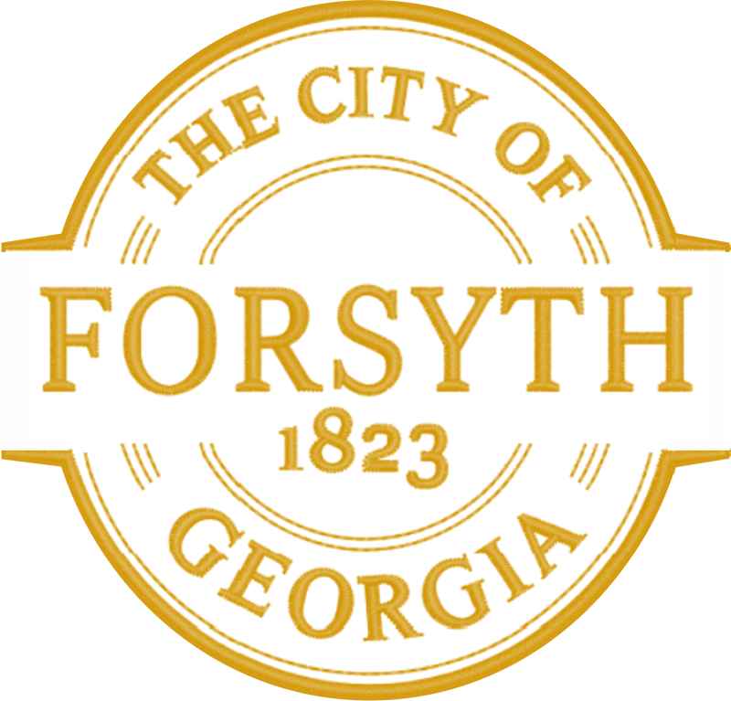

1. **Call to Order**
2. **Pledge of Allegiance, Invocation and Roll Call**
3. **Approval of the agenda**
4. **Approval of the minutes from the council meeting held on September 15, 2025**
5. **Public Hearing for the rezoning of tax parcel 054 009B**
6. **Approval of a street closure request on October 14, 2025 for a Candlelit Vigil.**
7. **Library Discussion**
8. **Walter Goodson**
9. **Tye Hanna**
10. **Approval of a Resolution for the Rescue Truck Lease purchase agreement.**
11. **Approval of bid award to Renfroe Construction for the Fleet Maintenance Building renovations.**
12. **Approval of payment to Davis Plumbing Company for an emergency utility relocation.**
13. **First Reading of the 2026 Proposed Budget**
14. **Approval of Requisitions Greater than $6,000**

* **Reed & Shows Meter Solutions- $8,800.00**
* **Gresco Utility Supply, Inc.- $65, 900.00**
* **Calibration Controls & Automation, Inc.- $8,025.15**

1. **City Manager’s Report**
2. **City Attorney Report**
3. **Mayor’s Report**
4. **Council Board Reports**
5. **Additional Business**
6. **Public Comments**
7. **Executive Session (if necessary)**
8. **Adjourn**

**Individuals with disabilities who require certain accommodations to allow them to observe and/or participate in this meeting, or who have questions regarding the accessibility of City Hall can contact the City Clerk, Shayla Furlow at 478-994-5649 or sfurlow@cityofforsyth.com. If additional accommodations are needed requests should be made as soon as possible but no less than 24 hours prior to the scheduled meeting.**