Agenda
Forsyth City Council Meeting
November 17, 2025
23 East Main Street @ 6:00 p.m.

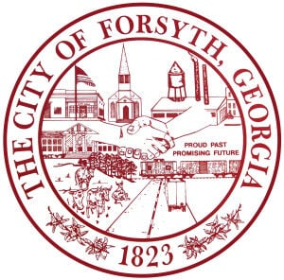

- Call to Order
- Pledge of Allegiance, Invocation, and Roll Call
- Approval of the agenda.
- Approval of the minutes from the council meeting held on November 3, 2025.
- Presentation of a Proclamation for the Golden Jubilee of the Monroe County Historical Society
- Approval of an alcohol license for 94 E. Adams Street, Ste. 3, Old Mill Tavern, LLC, Casey McCrea
- Library Board Appointment
- First reading of the Annexation and Zoning for tax parcel 041 013
- Water Task Force Update
- City Manager’s Report
- City Attorney Report
- Mayor’s Report
- Additional Business
- Public Comments
- Executive Session (if necessary)
- Adjourn

Individuals with disabilities who require certain accommodations to allow them to observe and/or participate in this meeting, or who have questions regarding the accessibility of City Hall can contact the City Clerk, Shayla Furlow at 478-994-5649 or sfurlow@cityofforsyth.com. If additional accommodations are needed requests should be made as soon as possible but no less than 24 hours prior to the scheduled meeting.

