Agenda
Forsyth City Council Meeting
November 3, 2025
23 East Main Street @ 6:00 p.m.

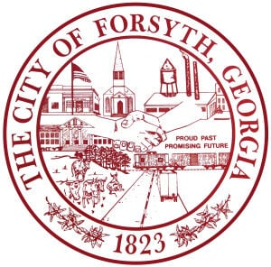

- Call to Order
- Pledge of Allegiance, Invocation and Roll Call
- Approval of the agenda
- Approval of the minutes from the council meeting held on October 20, 2025
- 2024 Audit Presentation by Davey King, Mauldin & Jenkins
- Public Hearing for the Annexation and Zoning of Tax Parcel 014 013.
- Approval of the Preliminary Plat Review for the Preserve at Fox Run, Phase 2, Parcels 054 019 and 054 019N.
- Approval of the Preliminary Plat Review for the Joshua Place Townhomes, N. Frontage Road, Parcel 053 001B,
a portion thereof.
- Approval of Surplus Equipment
- Adoption of the resolution for the proposed 2026 Budget
- Approval of the 2025 employee Christmas Bonuses.
- Tabled agenda item from September 15, 2025
- Consideration of a request for Hubbard Elementary and K.B. Sutton Elementary to use the Splash Pad and the allowance of inflatables.

- Approval of Requisitions Greater than $6,000
- MHC Kenworth- $10,130.38

- City Manager’s Report
- City Attorney Report
- Mayor’s Report
- Council Board Reports
- Additional Business
- Public Comments
- Executive Session (if necessary)
- Adjourn

Individuals with disabilities who require certain accommodations to allow them to observe and/or participate in this meeting, or who have questions regarding the accessibility of City Hall can contact the City Clerk, Shayla Furlow at 478-994-5649 or sfurlow@cityofforsyth.com. If additional accommodations are needed requests should be made as soon as possible but no less than 24 hours prior to the scheduled meeting.

