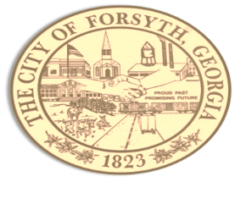

Agenda
Forsyth City Council Meeting
February 5, 2024
23 East Main Street @ 6:00 p.m.

- Call to Order
- Pledge of Allegiance, Invocation and Roll Call
- Approval of the agenda
- Approval of the minutes from the council meeting held on January 15, 2023.
- Workers Compensation Vendor Update Review – Richard Russell, Oakbridge Insurance.
- Approval of a service agreement with Linxup.
- Approval of bid award to 120 Water for lead service line inventory.
- Approval of bid award to Renfroe Construction for Country Club Park.
- Approval of MEAG Trust Signatories & resolution related to.
- Approval of a temporary permit for the sale of alcoholic beverages by Her Majesty, LLC on February 14, 2024.
- Approval of a temporary permit for the sale of alcoholic beverages by Fox City Brewing Co on March 8, 2024.
- Walter Goodson
- Library Board Appointment Discussion.
- Approval of Requisitions Greater than $6,000
- Industrial Chemicals, Inc $14,998.50
- Calibration Controls Inc $9,729.40
- GoForth Williamson $27,320.00

- City Manager’s Report
- City Attorney Report
- Mayor’s Report
- Council Board Reports
- Additional Business
- Public Comments
- Executive Session
- Adjourn

Individuals with disabilities who require certain accommodations to allow them to observe and/or participate in this meeting, or who have questions regarding the accessibility of City Hall can contact the City Clerk, Regina Ivie at 478-994-5649 or rivie@cityofforsyth.com. If additional accommodation are needed requests should be made as soon as possible but no less than 24 hours prior to the scheduled meeting.

