Agenda
Forsyth City Council Meeting
April 1, 2024
23 East Main Street @ 6:00 p.m.

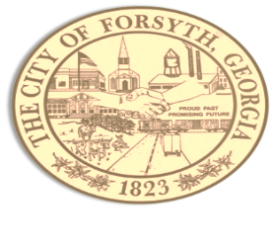

- Call to Order
- Pledge of Allegiance, Invocation and Roll Call
- Approval of the agenda
- Approval of the minutes from the council meeting held on March 18, 2024
- Approval of the Georgia Cities Week resolution.
- Presentation of the Government Finance Officers Association Award by Mayor Wilson.
- Presentation by Amwaste of Georgia, LLC.
- Approval of 3rd Amendment to contract with Georgia Waste Systems, LLC.
- Approval of new garbage and recycling rates.
- Approval of award bid for the Community Development Block Grant 2022
- Approval of the Municipal Electric Authority of Georgia’s 2023 Year-end settlement
- Approval of request to use the City Hall council chambers for Monroe County Reporter debate.
- Approval of street closure request on April 27, 2024 for The Pickled Okra.
- Approval of Requisitions Greater than $6,000
- Ten- 8 Fire & Safety- $9,562.58
- Custom Truck & Body Works, Inc.- $205,543.00
- Sunbelt Solomon Services, LLC- $23,600.00

- City Manager’s Report
- City Attorney Report
- Mayor’s Report
- Council Board Reports
- Additional Business
- Public Comments
- Executive Session
- Adjourn

Individuals with disabilities who require certain accommodations to allow them to observe and/or participate in this meeting, or who have questions regarding the accessibility of City Hall can contact the City Clerk, Regina Ivie at 478-994-5649 or rivie@cityofforsyth.com. If additional accommodations are needed requests should be made as soon as possible but no less than 24 hours prior to the scheduled meeting.

