**Agenda**

**Forsyth City Council Meeting**

**April 21, 2025**

**23 East Main Street @ 6:00 p.m.**

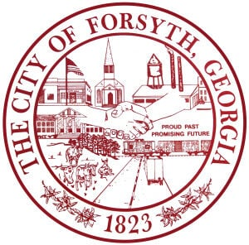

1. **Call to Order**
2. **Pledge of Allegiance, Invocation, and Roll Call**
3. **Approval of the agenda.**
4. **Approval of the minutes from the council meeting held on April 7, 2025.**
5. **Approval of the Supplemental Financial Advisory Services Agreement**
6. **Public Hearing to consider ordinance amendments to Sec. 23-119 and Sec. 23-120 of Chapter**

**23, Utilities, Article IV., Service Charges**

1. **Convention & Visitors Bureau Quarterly Report by Gilda Stanbery**
2. **Approval of the ballot for GMA’s District 6 Officers for 2025-2026.**
3. **Approval of street closure requests for the Main Street Concert Series**
4. **Approval of the Municipal Electric Authority of Georgia 2024 Year-end settlement**
5. **Tabled agenda items from April 7, 2025 council meeting**

* **Approval of funding for the golf course project**
* **Approval of Final Plat for Luxe Homes of Forsyth, 50 S. Jackson Street**

1. **Approval of bid award to R.J. Young for cameras at Country Club Park and Kynette Park**
2. **Approval of bid award to ICB Construction Group for Kynette Park**
3. **Approval of bid award to The Sign Store for the City Hall digital sign**
4. **Approval of Requisitions Greater than $6,000**

* **Industrial Chemicals, Inc- $14,998.50**

1. **City Manager’s Report**
2. **City Attorney Report**
3. **Mayor’s Report**
4. **Additional Business**
5. **Public Comments**
6. **Executive Session**
7. **Adjourn**

**Individuals with disabilities who require certain accommodations to allow them to observe and/or participate in this meeting, or who have questions regarding the accessibility of City Hall can contact the City Clerk, Shayla Furlow at 478-994-5649 or sfurlow@cityofforsyth.com. If additional accommodations are needed requests should be made as soon as possible but no less than 24 hours prior to the scheduled meeting.**