**Agenda**

**Forsyth City Council Meeting**

**June 16, 2025**

**23 East Main Street @ 6:00 p.m.**

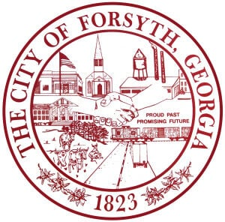

1. **Call to Order**
2. **Pledge of Allegiance, Invocation, and Roll Call**
3. **Approval of the agenda.**
4. **Approval of the minutes from the council meeting held on June 2, 2025.**
5. **James Green**
6. **Approval of the 2025 Budget Adjustment**
7. **Approval of a Lease Purchase Agreement with Altec Capital Services, LLC**
8. **Approval of Traffic Engineering Services**
9. **Tabled agenda Item from June 2, 2025 council meeting**

* **Approval of an Intergovernmental Agreement to provide funding for the Monroe County Public Library.**

1. **Second reading of the Text Amendment of Article 26 of the Zoning Ordinance**
2. **Second reading of Annexation and Zoning Ordinance for Parcels 015 010Z and 027 018A**
3. **City Manager’s Report**
4. **City Attorney Report**
5. **Mayor’s Report**
6. **Additional Business**
7. **Public Comments**
8. **Executive Session (if necessary)**
9. **Adjourn**

**Individuals with disabilities who require certain accommodations to allow them to observe and/or participate in this meeting, or who have questions regarding the accessibility of City Hall can contact the City Clerk, Shayla Furlow at 478-994-5649 or sfurlow@cityofforsyth.com. If additional accommodations are needed requests should be made as soon as possible but no less than 24 hours prior to the scheduled meeting.**