Agenda
Forsyth City Council Meeting
July 20, 2026
23 East Main Street @ 6:00 p.m.

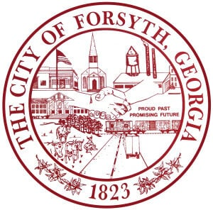

- Call to Order
- Pledge of Allegiance, Invocation, and Roll Call
- Approval of the agenda.
- Approval of the minutes from the council meeting held on July 06, 2025.
- 2027 Comprehensive Plan Update Presentation by Laura Mathis, MGRC
- Consideration of the ECG Electric Rate Proposal
- Approval of a street closure request on August 15, 2026 for the 3rd Annual City Fun Day
- Financial Update
- Approval of Requisitions Greater than $10,000
- Gresco Utility Supply, Inc.- $13,416.00

- City Manager’s Report
- City Attorney Report
- Mayor’s Report
- Additional Business
- Public Comments
- Executive Session( if necessary)
- Adjourn

Individuals with disabilities who require certain accommodations to allow them to observe and/or participate in this meeting, or who have questions regarding the accessibility of City Hall can contact the City Clerk, Shayla Furlow at 478-994-5649 or sfurlow@cityofforsyth.com. If additional accommodations are needed requests should be made as soon as possible but no less than 24 hours prior to the scheduled meeting.

