**Agenda**

**Forsyth City Council Meeting**

**July 7, 2025**

**23 East Main Street @ 6:00 p.m.**

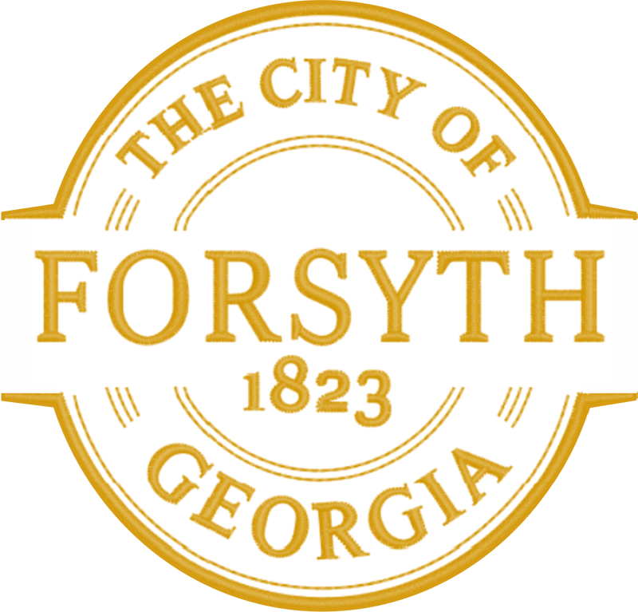

1. **Call to Order**
2. **Pledge of Allegiance, Invocation and Roll Call**
3. **Approval of the agenda.**
4. **Approval of the minutes from the council meeting held on June 16, 2025.**
5. **Approval of the appointment of Michelle Dublin to the Downtown Development Authority Board.**
6. **Approval of a Resolution authorizing Electric Cities of Georgia to enter into a tax-exempt loan.**
7. **Public Hearing for a Conditional Use Permit to allow clinic offices at 211 Tift College Drive, Parcel F35 051.**
8. **Public Hearing for a Maximum Height Restriction Variance Request for CityTec Design, LLC, Parcel**

**F25 014B.**

1. **Public Hearing for a Setback Variance Request for 483 Cabiness Road, Parcel F33 032.**
2. **Approval of bid award to Falcon Design Consultants for building permitting and inspection services.**
3. **Approval of Requisitions Greater than $6,000**

* **Electric Cities of Georgia- $72, 129.75**

1. **City Manager’s Report**
2. **City Attorney Report**
3. **Mayor’s Report**
4. **Council Board Reports**
5. **Additional Business**
6. **Public Comments**
7. **Executive Session**
8. **Adjourn**

**Individuals with disabilities who require certain accommodations to allow them to observe and/or participate in this meeting, or who have questions regarding the accessibility of City Hall can contact the City Clerk, Shayla Furlow at 478-994-5649 or sfurlow@cityofforsyth.com. If additional accommodations are needed requests should be made as soon as possible but no less than 24 hours prior to the scheduled meeting.**