Agenda
Forsyth City Council Meeting
August 17, 2026
23 East Main Street @ 6:00 p.m.

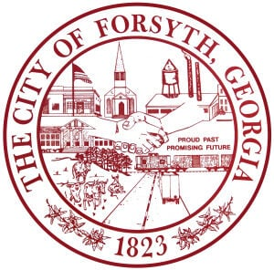

- Call to Order
- Pledge of Allegiance, Invocation, and Roll Call
- Approval of the agenda.
- Approval of the minutes from the council meeting held on August 3, 2026.
- Housing Authority Board Appointment
- Dean Darden
- Approval of the upfitting for two fire vehicles
- Set tentative 2026 millage rate and public hearing date
- Approval of Requisitions Greater than $10,000
- Industrial Chemicals, Inc.- $18,634.50
- Head Heating and Air - $7450.00

- City Manager’s Report
- City Attorney Report
- Mayor’s Report
- Additional Business
- Public Comments
- Executive Session
- Adjourn
Individuals with disabilities who require certain accommodations to allow them to observe and/or participate in this meeting, or who have questions regarding the accessibility of City Hall can contact the City Clerk, Shayla Furlow at 478-994-5649 or sfurlow@cityofforsyth.com. If additional accommodations are needed requests should be made as soon as possible but no less than 24 hours prior to the scheduled meeting.

