**Agenda**

**Forsyth City Council Meeting**

**September 15, 2025**

**23 East Main Street @ 6:00 p.m.**

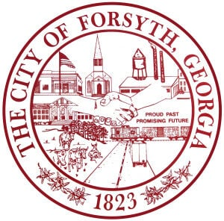

1. **Call to Order**
2. **Pledge of Allegiance, Invocation, and Roll Call**
3. **Approval of the agenda.**
4. **Approval of the minutes from the work session and council meeting held on September 2, 2025 and**

**the follow-up retreat on September 10, 2025.**

1. **Approval of a street closure request on October 11, 2025 for a Breast Cancer Motorcade by Psi Rho**

**Zeta- Zeta Phi Beta Sorority.**

1. **Alpa Panchal- Luxe Homes**
2. **Consideration of a request for the Monroe County Reporter to use the Council Chambers on**

**September 29, 2025 for a council debate.**

1. **Consideration of a request for Hubbard Elementary and K.B. Sutton Elementary to use the Splash**

**Pad and the allowance of inflatables.**

1. **Second reading of an Ordinance for the partial lot rezoning of Parcel 053 001B.**
2. **Approval of Requisitions Greater than $6,000**

* **Georgia Kenworth, LLC- $7,455.24**
* **GoForth Williamson, Inc- $13,635.00**

1. **City Manager’s Report**
2. **City Attorney Report**
3. **Mayor’s Report**
4. **Additional Business**
5. **Public Comments**
6. **Executive Session (if necessary)**
7. **Adjourn**

**Individuals with disabilities who require certain accommodations to allow them to observe and/or participate in this meeting, or who have questions regarding the accessibility of City Hall can contact the City Clerk, Shayla Furlow at 478-994-5649 or sfurlow@cityofforsyth.com. If additional accommodations are needed requests should be made as soon as possible but no less than 24 hours prior to the scheduled meeting.**